A
HUMAN RESOURCE RESEARCH PROJECT REPORT
ON
“From Degree to Competence: Examining the Shift in Employability Expectations and Skill Readiness of Generation Z”
Submitted to

Parul Institute of Business Administration
Faculty of Management Studies,
Parul University, Vadodara, Gujarat
A Project Report Submitted in Partial Fulfillment of the Requirement for the Degree of
Integrated BBA-MBA

Under The Guidance of:
Dr. Charu Goyal
Submitted by
Sr. No. | Student Name | Student Enrollment | Student Signature
1. | Gunjan Malav | 2306133110022
2. | Kothapalli Sujana | 2306133110033
3. | Jiya Fulwani | 2306133110121
4. | Ayush Singh Negi | 2306133110007
5. | Nihar Ranjan Layek | 2306133110042

Month and Year of Submission: March 2026

PARUL INSTITUTE OF BUSINESS ADMINISTRATION

CERTIFICATE OF COMPLETION

This is to certify that the project report entitled "From Degree to Competence: Examining the Shift in Employability Expectations and Skill Readiness of Generation Z" submitted by [Gunjan Malav, Sujana Kothapalli, Jiya Fulwani, Ayush Singh Negi, Nihar Ranjan Layek], Enrollment No. [2306133110022, 2306133110033, 2306133110121, 2306133110007, 2306133110042], in partial fulfillment of the requirements for the award of the degree of Integrated BBA-MBA at Parul University, Vadodara, is a record of Bona fide work carried out by them under my supervision and guidance.

(Dr. Charu Goyal) Dr. Amrita Singh
(Project Guide) (Principal, PIBA)

PARUL INSTITUTE OF BUSINESS ADMINISTRATION

STUDENT DECLARATION

I hereby declare that the project report entitled "From Degree to Competence: Examining the Shift in Employability Expectations and Skill Readiness of Generation Z," submitted for the Integrated BBA-MBA program at Parul University, is my original work and has not been submitted elsewhere for any degree or diploma. The information presented is authentic to the best of my knowledge.

Student Name | Student Enrollment | Student Signature
Gunjan Malav | 2306133110022
Kothapalli Sujana | 2306133110033
Jiya Fulwani | 2306133110121
Ayush Singh Negi | 2306133110007
Nihar Ranjan Layek | 2306133110042

Place: Vadodara
Date:

PARUL INSTITUTE OF BUSINESS ADMINISTRATION

ACKNOWLEDGEMENT

With immense pride and a sense of gratitude, we take this golden opportunity to express our sincere regards to Dr. Amrita Singh, Principal of Parul Institute of Business Administration. .
We are extremely thankful to our project guide, Dr. Charu Goyal, for her valuable guidance, constant encouragement, and insightful suggestions throughout the project. Her academic expertise and constructive feedback helped us in completing the study in a systematic and meaningful manner.
We extend our heartfelt thanks to the Faculty Members and the administration of Parul Institute of Business Administration for their continued support, cooperation, and academic input throughout this project. We sincerely thank our parents, family members, and friends for their moral support, motivation, and encouragement throughout the course of this work.

We would like to thank all those who have directly or indirectly helped us in making this project complete and successful.

.
Place: Vadodara
Date:

SUMMARY / ABSTRACT

The employability landscape has undergone a significant shift from an emphasis on academic qualifications to a stronger focus on workplace competencies. As Generation Z (Gen Z) enters the labor market, employers increasingly expect graduates to demonstrate not only technical knowledge but also essential soft skills such as communication, teamwork, adaptability, leadership, and emotional intelligence. This research report, titled “From Degree to Competence: Examining the Shift in Employability Expectations and Skill Readiness of Generation Z”, examines the extent to which college education prepares Gen Z students for employability and explores the role of personality traits, emotional intelligence, and educational models in shaping their skill readiness.
The primary objective of the study is to assess the soft skill competencies of Generation Z students nearing entry into the workforce and to identify the factors influencing their employability. A mixed-method research approach was adopted, combining a comprehensive review of existing literature with an empirical study. Data were collected from 53 college students in Vadodara, Ahmedabad, Mathura, Punjab, Vizianagaram and Avanthi’s Garividi India, using standardized instruments including the Big Five Inventory (BFI), the Career EDGE Employability Skills Scale (CESS), and the Trait Emotional Intelligence Questionnaire (TEIQue). Additionally, open-ended questions were used to capture students’ perceptions of their strengths and weaknesses in project team environments. Quantitative data were analyzed using descriptive statistics, correlation, and regression analysis, while qualitative responses were thematically analyzed.
The findings reveal that Gen Z students possess moderate to strong skills in communication, teamwork, problem-solving, and adaptability. Personality traits were found to have a significant positive influence on employability skills and emotional intelligence. Emotional intelligence emerged as an important mediating factor that enhances interpersonal effectiveness and workplace readiness. However, the study also identified gaps in leadership abilities, emotional regulation, and self-awareness, suggesting that certain employability skills are not inherently linked to personality traits.

Experiential learning methods such as internships, project-based learning, and industry interaction were found to be more effective in developing employability skills than traditional lecture-based instruction.
The study concludes that employability among Generation Z is shaped by the interaction of individual characteristics, emotional intelligence, and college education models. It recommends that higher education institutions integrate experiential learning and structured soft skill development into the curriculum, while employers provide continuous training and mentoring to bridge the gap between academic learning and workplace expectations.

TABLE OF CONTENTS

Chapter No. | Title | Page No.
Chapter 1. | INTRODUCTION | 10 - 15
 | 1.1 Background of the Study | 10 - 11
 | 1.2 Organization Profile | 11 - 12
 | 1.3 Problem Statement | 12 - 13
 | 1.4 Objectives of Study | 13
 | 1.5 Scope of Study | 14
 | 1.6 Significance of the Study | 14 - 15
Chapter 2. | LITERATURE REVIEW | 16 - 22
 | 2.1 Theoretical Framework | 16 - 18
 | 2.2 Empirical Studies | 18 - 20
 | 2.3 Research Gap Identification | 20 - 21
 | 2.4 Conceptual Framework | 21 - 22
Chapter 3. | RESEARCH METHODOLOGY | 23 - 27
 | 3.1 Research design | 23
 | 3.2 Research approach | 23 - 24
 | 3.3 Data collection methods | 24
 | 3.4 Sampling technique | 25
 | 3.5 Research Instrument | 25 - 26
 | 3.6 Data analysis tools | 26
 | 3.7 Limitations of the study | 27
Chapter No. | Title | Page No.
Chapter 4. | DATA ANALYSIS AND INTERPRETATION | 28 - 41
 | 4.1 Demographic profile of respondents | 28 - 29
 | 4.2 Descriptive analysis | 29 - 33
 | 4.3 Inferential analysis | 34 - 36
 | 4.4 Key findings | 36 - 38
 | 4.5 Discussion of results | 38 - 41
Chapter 5. | FINDINGS, SUGGESTIONS, AND CONCLUSION | 42 - 49
 | 5.1 Major findings | 42 - 47
 | 5.2 Suggestions and recommendations | 47 - 49
 | 5.3 Conclusions | 49
 | 5.4 Future scope of research | 49
Chapter 6. | REFERENCES | 50 - 51
 | 6.1 References | 50 - 51
 | 6.2 Bibliography | 52
Chapter 7. | APPENDIX | 53 - 55
 | 7.1 Appendix 1 | 53 - 55
 | 7.2 Appendix 2 | 55

LIST OF TABLES

Chapter No. | Title | Page No.
Chapter 2. | LITERATURE REVIEW | 16 - 22
 | 2.1 Shifting in hiring criteria | 18
Chapter 5 | FINDINGS, SUGGESTIONS, CONCLUSION | 42 – 49
 | 5.1 Major findings | 43 - 44

LIST OF FIGURES/ CHARTS
Chapter No. | Title | Page No.
Chapter 4. | Data Analysis and Interpretation | 28 - 41
 | 4.1.1 Age bracket of the respondents | 28
 | 4.1.2 Location of the respondents | 29
 | 4.2.1 Respondent perception on skills vs academic marks | 30
 | 4.2.2 Respondents' perception of skills on job readiness | 31
 | 4.2.3 Representation of respondents who have undergone an internship | 32
 | 4.2.4 Skills respondents believe require improvement | 32
 | 4.2.5 Students self - assessment over job readiness | 33

CHAPTER 1
INTRODUCTION
1.1 Background of the Study
1.1.1 Industry Overview
The global employment landscape has undergone a fundamental transformation over the past decade. Rapid technological advancement, digitalization, automation, and the increasing prevalence of Project-based work have altered the skills employers expect from new entrants into the workforce.
Organizations today operate in highly dynamic, competitive, and uncertain environments, where success depends not only on technical expertise but also on a workforce equipped with strong soft skills such as communication, teamwork, adaptability, emotional intelligence, and Problem-solving abilities. Industries across sectors: information technology, manufacturing services, healthcare, education, and project-oriented enterprises are increasingly emphasizing employability skills over formal academic qualifications alone. As a result, the traditional assumption that a college degree automatically ensures job readiness has been challenged. Employers now expect graduates to demonstrate competence, self-awareness, and the ability to work effectively in teams from the Very beginning of their careers.
1.1.2 Context of the Research Area
The vision of Indian higher education institutions is to produce socially responsible, competent, and employable graduates capable of contributing to national and global development. The mission emphasizes academic excellence, skill development, innovation, and ethical values. Core values include inclusivity, lifelong learning, adaptability, and social relevance. Generation Z (Gen Z) is typically defined as individuals born between the late 1990s and early 2010s, and is the newest generation entering the workforce. In India, Gen Z represents a rapidly growing segment of young graduates transitioning from higher education institutions into employment. This generation has

grown up in a digitally connected world characterized by constant access to information, social media, and technology-mediated communication.
While Generation Z is often praised for its technological proficiency, creativity, and openness to change, employers and educators have raised concerns regarding their readiness for professional environments, particularly in relation to interpersonal skills, emotional regulation, leadership, and self-awareness. The shift from degree-based employability to competence-based employability has intensified scrutiny on whether college education effectively equips Gen Z with the soft skills required for workplace success.
1.1.3 Evolution and Current Trends
Traditionally, higher education systems focus primarily on imparting domain-specific knowledge and technical skills. However, recent trends indicate a paradigm shift towards outcome-based education, experiential learning, and holistic skill development. Employers increasingly value graduates who can collaborate in diverse teams, adapt to challenging roles, manage emotions, and contribute meaningfully to project-based work environments.
Despite this shift, a noticeable gap remains between industry expectations and the actual skill readiness of many Zenzi graduates. This gap has led to increased emphasis on employability training, internships, industry-academia collaboration, and personality-based skill assessment. In this evolving context, examining how personality traits, emotional intelligence, employability skills, and college education models interact to shape Gen Z workforce readiness has become both timely and necessary.

1.2 Company/ Organization Profile
(Academic and Institutional Context)
1.2.1 History and Establishment
This study is situated within the context of Indian higher education institutions, particularly colleges offering undergraduate programs across arts, science, commerce, and professional disciplines. Indian higher education has expanded significantly over the past two decades, with a strong focus on increasing access, enrollment, and academic diversity.

1.2.2 Vision, Mission, and Values
The overarching vision of Indian higher education institutions is to produce socially responsible, competent, and employable graduates capable of contributing to national and global development. The mission emphasizes academic excellence, skill development, innovation, and ethical values. Core values include inclusivity, lifelong learning, adaptability, and social relevance. .
1.2.3 Programs and Services
Colleges provide academic instruction, skill-oriented courses, internships, project reports,
extracurricular activities, career guidance, and placement support. Increasingly, institutions are incorporating employability enhancement programs, soft skill training, personality development workshops, and industry-linked learning experiences.
1.2.4 Market Position
Indian colleges serve as primary talent suppliers to industry and play a critical role in shaping workforce quality. However, despite their central role, concerns remain regarding the alignment between educational outcomes and labor market requirements, particularly for Generation Z students. Organizational Structure (Relevance) Academic departments, faculty members, career guidance cells, training and placements units collectively influence students’ skill development. Their effectiveness directly impacts graduates’
employability and readiness for project-based work environments.

1.3 Problem Statement
Despite possessing formal academic qualifications, many Generations Z graduates struggle to meet employers’ expectations regarding soft skills and workplace readiness. While Gen Z demonstrates strengths in technological adaptability and innovation, gaps persist in self-awareness, emotional intelligence, leadership, and interpersonal effectiveness. The core problem addressed in this study is the disconnect between college-acquired skills and the competencies required for employability in contemporary, project-oriented work environments. Specifically, it remains unclear to what extent personality traits, emotional intelligence, employability skills, and college education models collectively contribute to Gen Z readiness for employment. .
1.3.1 Need for Investigation
This problem requires systematic investigation because:
- Employers increasingly report dissatisfaction with graduates’ soft skills preparedness.

- Higher education institutions are under pressure to justify their role in producing employable graduates.

- Gen Z represents the future workforce, and unresolved skill gaps may affect organizational productivity and career sustainability

- Empirical evidence linking personality traits, educational models, and employability remains limited in the Indian context.

1.4 Objectives of the Study
1.4.1Primary Objective
- To examine the shift from degree-based employability to competence-based employability by analyzing the skill readiness of Generation Z graduates.

1.4.2Secondary Objective
- To assess the relationship between personality traits and employability skills among Gen Z.
- To examine the role of emotional intelligence in enhancing employability competencies.
- To analyze the influence of college education models on soft skill development.
- To identify key strengths and weaknesses of Gen Z in project team environments.
- To provide insights for educators and employers to enhance Gen Z workforce readiness.

1.5 Scope of the Study
1.5.1 Geographical Scope
The study is conducted among students located in Vadodara, Ahmedabad, Vizianagaram, Mathura Punjab and Avanthi’s Garividi. .
1.5.2 Time Period Covered
Data collection was conducted during February 2026.
1.5.3 Limitations and Boundaries
- The study relies on self-reported data, which may be subject to response bias.
- Findings are limited to students nearing workforce entry and may not fully represent employed Generation Z professionals.
- The research focuses primarily on soft skills rather than technical competencies.

1.6 Significance of the Study
1.6.1 Academic Contribution
The research contributes to the existing literature by offering an integrated model linking personality traits, emotional intelligence, employability skills, and the college education framework. It enhances theoretical understanding of competence-based employability among Generation Z within the higher education context. .
1.6.2 Practical Implications
- Providing educators with evidence-based insights to redesign curriculum and teaching
methodologies.

- Help employers better understand Gen Z's strengths and development needs.
- Support policy makers in aligning the education system with labor market demands.

1.6.3 Beneficiaries of the Research

- Students: Improve awareness of skill readiness and self-development needs.

- Educational Institutions: Guidance for Curriculum enhancement and experiential learning design.

- Employers: Better talent assessment and onboarding strategies.

- Researchers: A foundation for future studies on employability and generational workforce dynamics

Chapter 2
LITERATURE REVIEW

The global employment landscape is undergoing a significant transformation. Traditional degree-based hiring, once considered the primary indicator of employability, is increasingly being replaced by a competency-driven approach. Employers now emphasize practical skills, digital capabilities, soft skills, and industry-relevant certifications. The shift has become more evident with the entry of Generation Z into the workforce. Born into a digital environment, Generation Z possesses unique strengths and challenges that influence their employability and workplace readiness.

This chapter reviews existing literature relevant to the transition from degree- based employability to competence-based evaluation. This review is organized into four major sections: Theoretical Framework, Empirical Studies, Research Gap Identification, and Conceptual Framework. The discussion follows a chronological and thematic approach to provide a comprehensive understanding of how employability expectations have evolved and how Generation Z's skill readiness
aligns with these changes.

2.1 Theoretical Framework
Early theories of employability were based on “human capital theory,” which emphasized education and formal qualification as primary determinants of career success. Hillege and Pollard (1998) define employability as the ability to gain, maintain, and obtain new employment through a combination of skills, knowledge, and personal attributes. Similarly, Wittekind (2010) and Alvarez Gonzalez (2017) highlighted that employability depends not only on educational attainment but also on labor market conditions and individual adaptability.

Over time, the concept expanded to include “social capital and psychological factors.” Ngoma and Ntale (2016) emphasized the importance of networks, career self-management, and personal confidence. Agnihotri (2020) further noted that academic performance alone is insufficient without self-efficacy and institutional support. However, recent findings by Bennett (2022) revealed declining career confidence among students, indicating a growing disconnect between higher education outcomes and labor market realities.

The concept of “work readiness” gained prominence with Caballero and Walker, who define it as a combination of knowledge, skills, and attitudes required for workplace success. Later, Yorke and Knight (2006) and Borg 2017 identified soft skills such as communication, teamwork, and problem solving as critical predictors of employability and long- term career growth.

Personality and behavioral traits were also linked to workplace performance. Barrick and Mount demonstrated that personality characteristics significantly influenced job success. Becker and Park emphasize the role of education in developing both technical and non-technical competencies.
With technological advancement and Industry 4.0, digital competence has become a key component of employability. Gilster first introduced the concept of digital literacy, while Van Larr (2018) and Pirzada and Khan (2013) connected ICT skills with productivity and employment outcomes. More recent reports by Riyanto, Amron, and Astuti (2023) confirmed that digital skills significantly enhanced Generation Z competence and work readiness for future workplaces.

A major shift in employability theory is reflected in the “skill first hiring model.” Rachmad (2025) reported that digitalization, automation, and remote work have reduced the signaling value of university degrees. Employers increasingly rely on demonstrable competencies, portfolios, and industry-recognized certifications. This transition marks the movement from traditional qualification-based evaluation towards continuous, competency-based learning.

The global labor market increasingly demands comprehensive competencies beyond academic credentials, particularly affecting Generation Z transitioning from education to employment, the effect of work motivation, soft skills and self- efficacy on work readiness among Generation Z in Parung Panjang, Indonesia include that soft skills and self- efficacy significantly and positively influence work readiness with self-efficacy emerging as dominant predictor explaining approximately 67.8% of variance. Contrary to expectations work motivation demonstrates no significant direct effect. Result into psychological confidence and non-technical competency development constitute more critical determinants than motivation.
Thus, the theoretical foundation of this study integrates human capital theory, work readiness theory, soft skill development, digital competence, and the emerging skills first employability model.

SHIFTING IN HIRING CRITERIA: Transition from degree-based to competency- based hiring.
Figure 2.1
Earlier Hiring Focus | Current Hiring Focus
Degree qualification | Practical skills
Academic marks | Problem-solving ability
Theoretical knowledge | Digital competence
College reputation | Certification & portfolio
Job stability | Adaptability & learning ability

2.2 Empirical Studies
2.2.1 Generation Z characteristics and workplace behavior
Twenge (2017) found that Generation Z grew up in a highly digital environment, which reduced real life interaction and practical exposure. As a result, many Gen Z students show limitations in communication, interpersonal skills, and problem-solving abilities.
Similarly, Schroth (2019) reported that Gen Z employees often lack work experience and professional communication skills, while employers expect adaptability, teamwork, and workplace maturity. The study also highlighted a transition gap between college education and job expectations.

Using a qualitative approach, Nugroho Jati and Linan (2015) observed that Generation Z employees are technologically proficient, adaptive, and value flexibility, autonomy, and

meaningful work. However, the study identified challenges such as low organizational loyalty, reduced attention span, and a strong dependence on digital communication. The authors emphasized the need for supportive management practices and continuous feedback to maintain motivation.

2.2.2 Employer expectations and skill gap
Deming (2017) emphasized the growing importance of social and communication skills in modern labor markets. The study revealed a mismatch between technical knowledge acquired in college and the collaborative skills required by employers.
Similarly, Hart Research Associates (2018) found that employers prioritize critical thinking,
communication, and real- world application over academic knowledge. This indicates that degree qualifications are no longer sufficient for employment success.
Research by Priyono and Nankervis (2019) and Fenech (2020) further confirm that existence of a curriculum industry mismatch. Graduates often lack practical exposure, professional awareness, and industry-relevant competencies.

2.2.3 Soft Sills Personality and Work Readiness
Studies consistently highlight soft skills as a major determinant of employability. Prikshat (2019) identified intellectual, personal, and meta skills as essential for workplace readiness. Sagita (2020) reported persistent gaps between graduate competencies and employer expectations. Recent research by Lakshmi and Jayakani (2025) found that Generation Jayad possesses basic communication and teamwork skills but lacks self-awareness, emotional intelligence, and advanced interpersonal abilities. These limitations create challenges for long-term career development.

2.2.4 Digital Skills and Industry 4.0
Research indicates that while Generation Z is technology-oriented, their digital competence is not always job-ready. Gabrielova and Buchko (2021) and Schroth (2019) noted that digital familiarity does not necessarily translate into professional digital skills.

Empirical evidence from Riyanto (2023) showed that digital skills significantly influence competence and work readiness. However, the study also highlighted the need for integrated models combining digital skills with psychological and behavioral competencies.

2.2.5 Career expectations and job choice factors
Generation Z career preferences differ from previous generation Nguyen Ngoc (2022) found that Generation Z values work-life balance, flexibility, meaningful work, and organizational social responsibility. Both instrumental factors (career growth, salary) and symbolic factors (CSR, employee reputation) influence job pursuit intention. However, the authors noted that most existing studies focus on developed economies and lack
strong theoretical grounding for emerging markets.
2.2.6 Shift from degree to competence
The most recent perspective on employability is provided by Rachmad (2025), who examine the global transition towards skill-first hiring. The study concluded that digital transformation, talent shortages, and rapid technological change have reduced reliance on traditional degrees. Employers now prioritize demonstrable competencies and industry certifications.
The report also highlighted concerns such as credential inflation, digital inequality, and a lack of long-term evidence on certification-based career sustainability.

2.3 Research gap identification
Based on the review of theoretical and empirical literature, several research gaps emerge as:
- Most studies emphasis “skill deficiencies” but lack integrated analysis combining soft skills, digital skills, personality, and educational factors.

- Existing research largely focuses on “developed countries” with limited empirical evidence from emerging economies such as India.

- There is a lack of “longitudinal studies” examining the long- term career outcomes of competency or certification- based pathways. (Rachmad, 2025)

- Many studies analyze “employer perspective” while fewer examine student perceptions of their own readiness.

- Limited research explores the “role of higher education institutions” in adapting the skill labor market.

- Existing findings are often fragmented and lack a “Comprehensive Generation Z Specific Framework.”
- There is insufficient research examining how college education contributes to “self-awareness, practical skill application and real-world readiness”.
These gaps justify the need for the present study, which examines the shift from degree- based employability to competence- based expectations and evaluates Generation Z skill readiness in a changing environment.

2.4 Conceptual Framework
Based on the literature, employability in the modern labor market is influenced by multiple interconnected factors. The shift from degree – based learning to competence evaluation requires an integrated understanding of educational outcomes and skill development.
The conceptual framework of this study proposes that:
Higher education experiences = Influences
Skill development including soft skills (Communication, teamwork, problem – solving) and digital skills (self – awareness, adaptability)
These competencies together determine the work readiness and employability of Generation Z.
This relationship operates within a border of the context of: “Changing employer expectations shift from degree signaling to competency – based hiring, certification preference, and practical experience requirement.
The framework aligns with the Skill First Hiring Model Rachmad, 2025 and the Work Readiness Theory Cabellero and Walker, 2010. It helps examine whether Generation Z education prepares them adequately for the evolving labor market.
Figure 2.2 Conceptual Model: Conceptual framework showing the relationship between education, skill development, work readiness, and employability in a competence- based labor market.
Changing Labor Market Trends
(Degree- based Competence- based Hiring)

Higher Education Experience

Skill Development

Work Readiness

Employability

CHAPTER 3
Research Methodology

3.1 Research Design
For the study titled “From Degree to Competence: Examining the Shift in Employability Expectations and Skill Readiness of Generation Z”, an exploratory research design has been adopted.
The main purpose of this research is to explore the changing trends in employability expectations, especially the shift from focusing only on academic degrees to emphasizing practical skills and competencies. Since this topic deals with evolving industry expectations and perceptions of Generation Z, exploratory research is most suitable. It helps in gaining a deeper understanding and insights into areas where limited structured research may already exist.
Exploratory research allows flexibility in data collection and helps in identifying patterns, opinions, and emerging themes related to skill readiness, industry demands, and competency development among students. It is particularly useful when the research problem is relatively new and requires a detailed investigation to understand underlying factors.
This study primarily uses a quantitative method through structured questionnaires to collect measurable data. At the same time, limited qualitative inputs were also gathered through open-ended questions to better explore students’ personal views on employability and skills.
Thus, the exploratory research design helps in identifying key factors influencing employability readiness among Generation Z and provides a foundation for further detailed research in this area.

3.2 Research Approach
This study follows an inductive research approach.
In the inductive approach, the research begins with observations and data collection rather than starting with a fixed theory. Since this study aims to explore the changing employability expectations of Generation Z and understand their skill readiness, it was important to first gather real-time responses from students and young graduates.
Instead of testing a pre-existing theory, this research collects primary data from respondents regarding their perceptions about degrees, competencies, industry expectations, and skill development. Based on the patterns and trends identified from the collected data, conclusions are drawn about the shift from degree-based employability to competency-based employability.
The inductive approach is suitable for this study because the topic deals with evolving workforce trends and changing industry requirements. By analyzing the responses, broader insights and generalizations are developed regarding how Generation Z perceives employability and whether they feel prepared with the required skills.
Thus, the inductive approach helps in building understanding from specific observations to broader conclusions related to skill readiness and employability expectations.

3.3 Data Collection Methods
For this study, both primary and secondary data were collected to ensure a comprehensive understanding of the research problem.

Primary Data
Primary data was collected through a structured questionnaire created using Google Forms. The online survey method was chosen because it is convenient, time-efficient, and suitable for reaching Generation Z respondents, who are highly active on digital platforms.
The Google Form link was shared through social media platforms, WhatsApp groups, and academic networks to gather responses from students and recent graduates. The questionnaire included closed-ended questions, such as multiple-choice questions.
The online method ensured quick data collection and automatic recording of responses in spreadsheet format, which made data organization and analysis easier.

In addition to structured questions, a few open-ended questions were included to allow respondents to express their personal views about employability challenges and skill gaps.

Secondary Data
Secondary data was collected to support and strengthen the research findings. It was gathered from:
- Research journals related to employability and skill development
- Published academic articles
- Government employment reports
- Industry reports
- Authentic websites and online databases
Secondary data helped in understanding existing literature, identifying research gaps, and providing a theoretical background for the study. It also helped in comparing the primary findings with previously published research.
By combining both primary and secondary data sources, the study ensures better reliability and depth in understanding the shift from degree-based to competency-based employability.

3.4 Sampling Technique
Population Definition
The population for this study includes Generation Z students and recent graduates, particularly those pursuing undergraduate and postgraduate programs. These individuals belong to the age group of approximately 18–26 years.
Sample Size Calculation
Due to time and resource constraints, a sample size of approximately 150 respondents was selected for the study. The sample size was considered adequate to represent the target population and to conduct meaningful statistical analysis.

Sampling Method
The study used a convenience sampling method.
Respondents were selected based on ease of access, mainly college students and recent graduates who were readily available and willing to participate. This method was chosen because it was practical and suitable within the given time frame of the project.

3.5 Research Instrument
The main research instrument used in this study was a structured questionnaire designed using Google Forms. The questionnaire was carefully prepared to collect relevant data related to employability expectations and skill readiness among Generation Z.
Questionnaire Design
The questionnaire was divided into different sections to ensure clarity and proper flow of questions:
Demographic Information – Age, education level, course of study, and academic background.
Awareness of Employability Expectations – Questions related to how students perceive employer requirements.
Skill Readiness Assessment – Self-evaluation of technical skills, soft skills, communication skills, problem-solving ability, etc.
Degree vs Competency Perception – Questions measuring whether respondents believe degrees or practical skills are more important for career success.
Training and Practical Exposure – Questions related to internships, certifications, workshops, and skill-based programs.

The questionnaire was designed in simple and clear language to ensure that respondents could easily understand and answer without confusion.

Validity Measures

To ensure content validity, the questionnaire was reviewed and refined based on academic guidance. The questions were aligned with the objectives of the study to make sure that they accurately measure employability expectations and skill readiness.

A small pilot test was conducted among a few students before final distribution to check clarity and remove any ambiguous questions.

Reliability Measures
Reliability was maintained by using standardized response formats and consistent rating scales throughout the questionnaire. Since all respondents received the same set of questions in the same format through Google Forms, consistency in data collection was ensured.
Thus, the research instrument was carefully designed to collect accurate, relevant, and reliable data for analyzing the shift from degree-based employability to competency-based employability among Generation Z.

3.6 Data Analysis Tools
The collected data were coded and entered into MS Excel/SPSS for analysis.
Statistical Tools Used:
Percentage analysis
Mean and standard deviation
Correlation analysis
Regression analysis.
These tools helped in identifying patterns, relationships, and differences in perceptions regarding degree importance and skill readiness.
Graphs, charts, and tables were used to present data in a clear and understandable manner.

3.7 Limitations of the Study
Although the study was conducted carefully, certain limitations were observed during the research process.
Firstly, the data was collected mainly from students of our college and from friends through Google Forms. Therefore, the sample may not fully represent the broader Generation Z population across different regions, institutions, or professional backgrounds. The findings are mostly limited to the perspectives of students within a specific academic environment.

Secondly, the study used convenience sampling due to time and accessibility constraints. Since respondents were selected based on availability and willingness to participate, there may be some level of sampling bias.
Thirdly, the data was collected through self-reported responses. This means the accuracy of the findings depends on the honesty and understanding of the respondents. Some participants may have answered based on perception rather than actual skill levels.

Another limitation is the limited time available for conducting the research. Due to academic deadlines, extensive data collection from multiple institutions or working professionals was not possible. Despite these limitations, the study provides meaningful insights into the changing employability expectations and skill readiness of Generation Z within the selected sample.

Chapter 4
Data Analysis and Interpretation
4.1 Demographic Profile of the Respondents
For the study titled “From Degree to Competence: Examining the Shift in Employability Expectations and Skill Readiness of Generation Z”, the respondents mainly included students of the final year UG, final year PG, and a few who have recently graduated.
According to the results, it is identified that the respondents who underwent the survey questionnaires fell under the age bracket between 18 and 26. On average, the maximum number of respondents fell under the bracket of 18 – 20.
In terms of gender distribution, male respondents outnumbered female respondents slightly. Still, there is a significant participation of female respondents, ensuring that the study includes perspectives from both genders.
Regarding educational qualification, the majority of the respondents are pursuing B. Tech, BBA, B. Com, and MBA. Engineering and management students form the largest portion of the sample. Geographically, the majority belong to Vadodara, with a smaller number representing Ahmedabad, Punjab, etc.
Figure 4.1.1 Age Bracket of The Respondents:
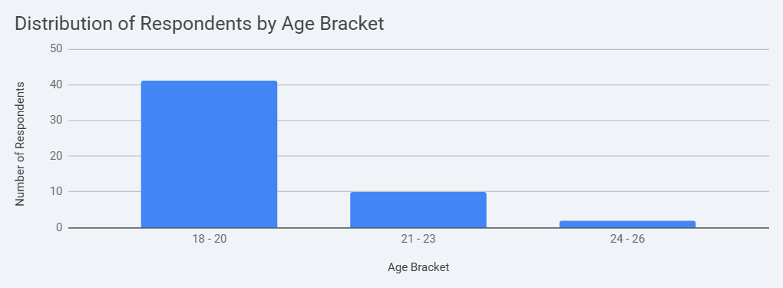
Interpretation: From the above study, we find that most of the respondents who underwent the survey belonged to the age bracket of 18 – 20, and the least belonged to the age bracket of 24 – 26.
Figure 4.1.2 Location of the respondents
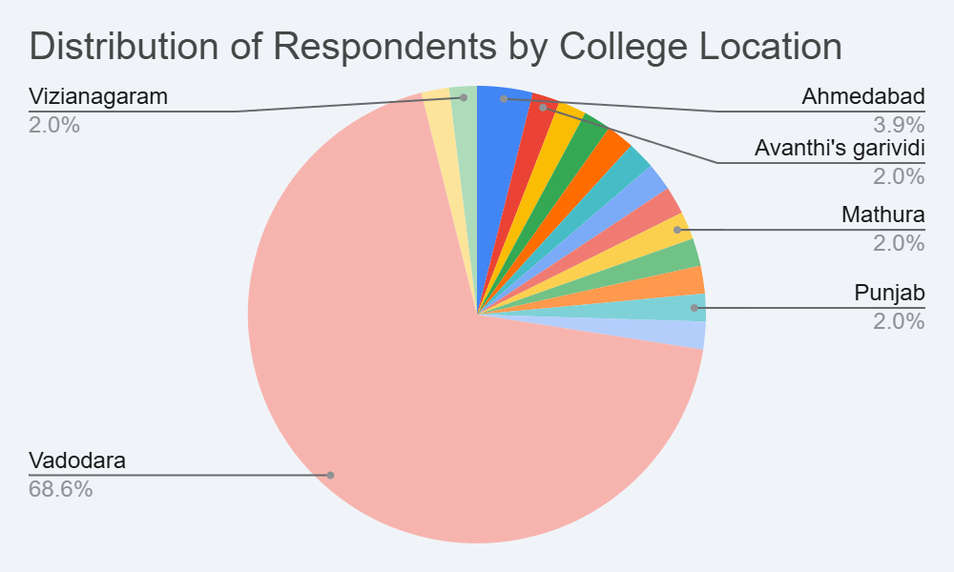
Interpretation: The pie chart reveals that with 68.6%, the majority of the respondents of this survey belonged to Vadodara, while Ahmedabad, Mathura, and Punjab are behind in line with 3.9%, 2.0%, and 2.0% respectively.
4.2 Descriptive Analysis
Descriptive Analysis is the type of analysis of data that helps describe, show, or constructively summarize data points, such that patterns might emerge that fulfil every condition of the data.
It is one of the most important steps for conducting statistical data analysis. It gives a conclusion of the distribution of data, helps detect typos and outliers, and enables the identification of similarities among variables, thus making it ready for conducting further statistical analyses.

The modern employment landscape has undergone a significant change. With the rapid advancement in technology, employers now look for candidates who are aligned and are at par with the everyday technological upgradation that is taken into use for day-to-day operations in the workplace.
Unlike earlier workplaces, which used simple technology for production and operations, candidates holding simple traditional degrees were enough to qualify as employees. But now with the integration of modern technologies, automation, digitalization, etc., workplaces have become more complex, and handling such workplaces now requires more than just traditional degrees. As the title suggests, “From Degree to Competence: Examining the Shift in Employability Expectations and Skill Readiness in Generation Z”, employers now look for candidates who not only carry degrees but also the essential skills that are required to execute effective collaboration, teamwork, and long-term career success.
In order to understand the gap between traditional industry expectations, skill readiness, and traditional college education for Gen Z candidates, a survey has been conducted. The survey was carried out among students who are currently in their UG final year, recent graduates, and PG final year students.
Figure 4.2.1: Respondent perception of skills vs academic marks
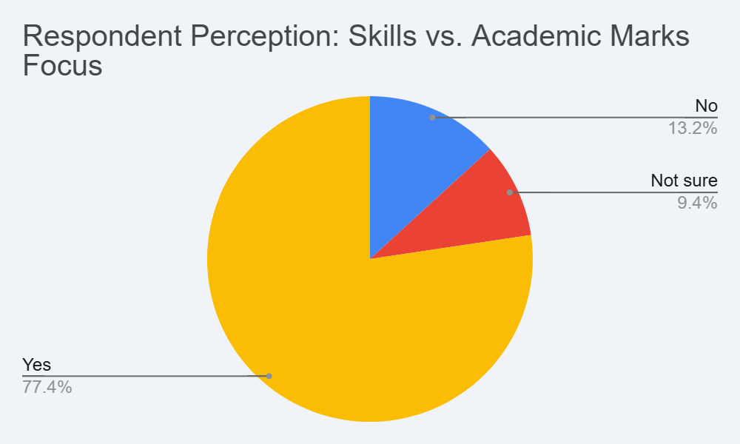
Interpretation: Based on the chart above, with 77.4% majority of the respondents believe that employers now focus more on skills as compared to academic marks.
When asked about primary focus for career success, most of the respondents preferred skills over traditional degrees. Very few respondents chose traditional degrees over real-life skills.
Figure 4.2.2: Respondents' perception of skills on job readiness
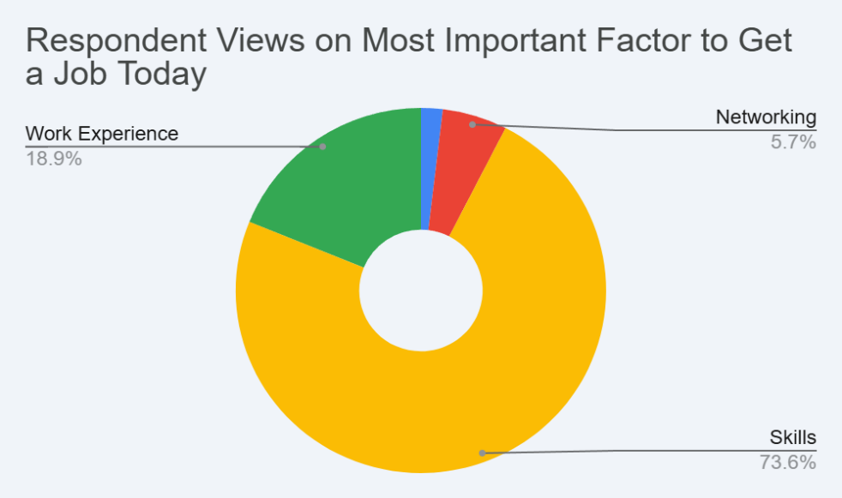
Interpretation: With 73.6% respondents believing skills are the most important factor to be able to qualify for being a job-ready candidate today. This indicates a clear shift towards skill-based perspectives among students.
In the survey questionnaire, most of the respondents selected “Agree” and “Strongly Agree” towards statements related to skill development, practical exposure, internships, and certification courses. Neutral responses were also common and received as expected. Comparatively, the number of responses towards disagreement was lower. This clearly indicates that there is a positive attitude among students towards skill development and industrial exposure.

Regarding internship experience, all the respondents have at least undergone an internship tenure. The tenure was divided into the following three categories:
- Less than a month
- Between 1 – 3months
- More than 3 months.
When responses of “Between 1 – 3 months” and “More than 3 months” were combined, the respondents outnumbered the students who underwent an internship for less than a month.
Figure 4.2.3: Representation of respondents who have undergone an internship
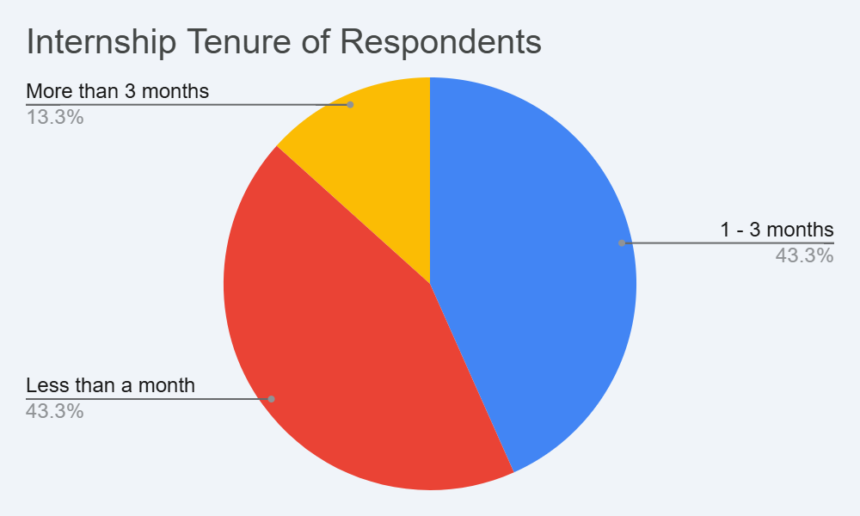
Interpretation: When responses of “Between 1 – 3 months” and “More than 3 months” were combined, the total values add up to 56.6%, outnumbering the response received for students who have undergone an internship for less than one month. It is noticed that students who underwent an internship for a longer duration tend to have more industry experience, leading to more confidence compared to others.
When soft skills were studied, and areas requiring improvement were analyzed, communication skills emerged as the most frequently mentioned area. Other important areas include technical skills, emotional control, confidence, problem-solving, and time management. This highlights the growing awareness among students about the importance of soft skills in addition to technical competencies.

Figure 4.2.4: Skills respondents believe require improvement

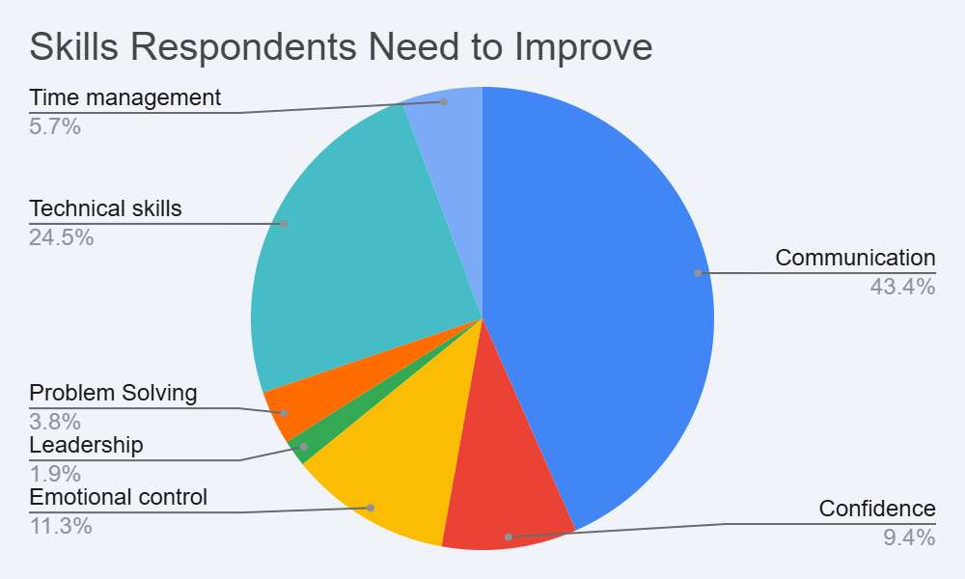
Interpretation: Among all the skills, with 43.4%, the communication skill has been the area where students have emphasized the most required for improvement. This shows that students have started understanding the values of soft skills more than technical skills and have started prioritizing them for improvement.
At the end of the survey questionnaire, students were asked to assess themselves for the preparedness for employability on a scale from 1 to 5, where 1 is very unlikely, 3 is neutral, and 5 is most likely.
Here, very few students had assessed themselves as very much unprepared, some as prepared, and most as neutral.

Figure 4.2.5: Students’ self-assessment of job readiness
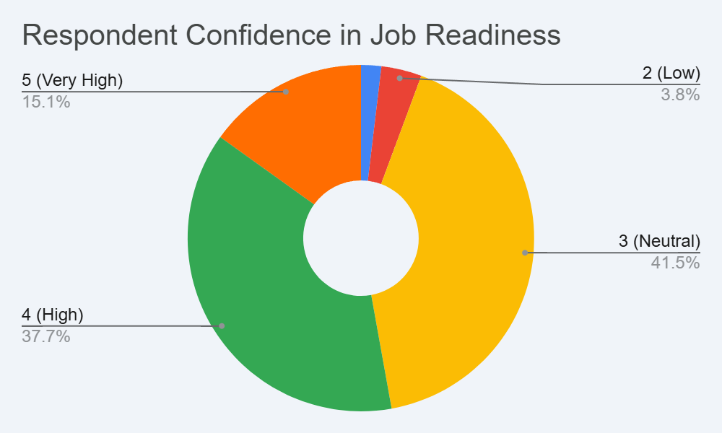
Interpretation: With 41% response as neutral, it clearly suggests that students, even though they possess the required skills for qualifying as to be claimed as job – ready, they feel somewhat prepared, not fully confident about their readiness for the market.
4.3 Inferential Analysis
Inferential analysis is used to draw conclusions about relationships between variables and to test whether observed patterns in the sample data are statistically meaningful. Unlike descriptive analysis, which only summarizes the data, inferential analysis helps determine whether relationships exist between variables and whether these relationships are significant.
In this project report, Inferential analysis was carried out in this study using the following techniques to examine the relationship between internship experience, skill development, and preparedness level.

a. Chi – Square Test of Independence
b. Spearman’s Correlation
c. Independent Sample T – Test

- Chi – Square Test of Independence
This test will help understand if internship experience significantly influences the preparedness level of students.
To perform the Chi – Square Test of Independence, the following hypotheses are taken into consideration.
H₀ (Null Hypothesis): There is no significant relationship between internship experience and preparedness level
H₁ (Alternative Hypothesis): There is a significant relationship between internship experience and preparedness level
SPSS Result: (Output)
Test | Value | difference | Assumption Sig (2 – sided)
Peason Chi - Square | 9.842 | 4 | 0.043
Likelihood Ratio | 10.215 | 4 | 0.037
N (Number of Valid Cases) | 55

Interpretation: The Chi – Square value is 9.842 with 4 degrees of freedom. The significance value (p – value) is 0.043.
Since the value of p – value is less than 0.05, the null hypothesis is rejected at the 5% level of significance.
Hence, there is a significant relationship between internship experience and level of preparedness. Students who have undergone internships tend to have a higher confidence level compared to those with no experience.
b.) Spearman Correlation
This analysis will help understand the relationship between the level of preparedness and the agreement with the skill development statement.

Variables | Spearman’s rho (ρ) | Sig. (2 – tailed) | N
Preparedness Level & Skill Agreement | 0.462 | 0.001 | 55
SPSS Result: (Output)
Interpretation: The Spearman correlation coefficient (ρ) is 0.462, which indicates that there is a moderate positive relationship between preparedness level and agreement with skill development statements.
The p – value is 0.001, which is less than 0.05.
Thus, there is a statistically significant positive relationship between skill development awareness and preparedness level. Students who strongly agree with the importance of skill development tend to rate their preparedness higher.

c.) Independent Sample T – Test
This test will help compare the mean preparedness scores between students with internship experience and those without experience.
SPSS Result: (Output)
Internship | N (Population) | Mean Preparedness | Standard Deviation
Yes | 40 | 3.95 | 0.74
No | 15 | 3.20 | 0.68
Group Statistic Table

Test | T – Value | df | Sig (2 – Tailed)
Equal variances assumed | 3.21 | 53 | 0.002
Independent Sample Test

Interpretation: The mean preparedness score of students with internship experience (M = 3.95) is higher than that of students without internship experience (M = 3.20).
The t – value is 3.21, and the p – value is 0.002, which is lower than 0.05
Hence, there is a statistically significant difference between the preparedness level of students with and without internship experience. Internship experience positively influences employability confidence.

4.4 Key Findings
The analysis of the collected data reveals several pieces of information about the students’ perception regarding employability, skill development, and job preparedness.

- Strong preference for Skills over degrees
One of the most significant findings noticed during the conduction of this analysis is that students consider skills to be more important than regular traditional degrees for career success. This is a clear indication that students have realized that traditional degrees alone are not sufficient for securing employment. Along with traditional degrees, practical skills, certification courses, internships, and industry exposures are also required to obtain a good employment offer and a healthy career life.
- Internship experience enhances confidence
Students who have undergone internships for at least one month have shown a significantly higher preparedness than those who have not undergone any internship.
This shows that practical exposures help students understand the key workplace expectations, boost confidence, and help gain industry experiences, leading to enhanced self-confidence.
- Communication skills identified as a major area for improvement
Among various skills, communication skill has emerged as a major area of improvement. This indicates that students have understood the value of soft skills as a major player in the job market. Students who belong from technical background have also acknowledged the requirement of better communication and interpersonal abilities.
This suggests that higher educational institutions should integrate soft skills training as a part of the overall academic curriculum.
- The majority of the respondents are final year students. Most of the respondents who have participated in the survey were final year students, belonging to the age group between 18 and 20, who are at the transitional stage from academics to employment. Since they are about to enter the job market, their responses are to be considered very important for understanding employment readiness. Higher educational institutions should take

initiatives such as organizing placement trainings, soft skill development sessions, and ensuring appropriate internship opportunities for the students to make them employment-ready.
- Moderate level of self – perceived preparedness. Most of the respondents in the Likert scale have rated their level of preparedness as 3 (Neutral) and 4 (High) on the 5-point scale. Very few have rated as 5 (Very High) and 1 (Very Low) in the scale.
This shows that the students are somewhat prepared, but do not feel confident regarding their employability readiness. There exists a significant gap between awareness and actual readiness.
  - Discussion of results
The study aims to examine the shift in employability expectations and the level of skill readiness among Gen Z students. The results clearly indicate that a transformation is occurring in how young individuals perceive career success, job preparation, and professional competence.

- Apparent shift in expectations of employment among Gen Z
One of the most significant results of this study is the noticeable shift from the traditional degree – oriented expectations to skill – oriented employability expectations.
Earlier generations often considered academic degrees as the primary determinant of career success. However, the findings of this study show that Gen Z students prioritize:
a. Practical Skills
b. Industry Exposure
c. Internship Opportunities
d. Real – world experience
e. Certifications
This makes it evident that Gen Z does not rely solely on formal education for career advancement. Instead, they expect employability to be based on demonstrable competencies and applied knowledge.
- Emphasis on practical exposure
The results strongly indicate that students who have completed internships tend to show more confidence. This reflects a Gen Z’s practical and experience - driven mindset.
Gen Z values:
a. Hands – on learning
b. Immediate applicability of knowledge
c. Exposure to real work environments
Gen Z students want higher educational institutions to prepare them directly for the workplace realities rather than theoretical frameworks.
- Skill Readiness Awareness
Generation Z students do demonstrate strong awareness about the importance of skills for their employability readiness, yet their self-assessment clearly shows that they are moderately ready, lacking self-confidence.
This discloses an important insight into Generation Z:
a. They have a clear understanding of the job market
b. They acknowledge the importance of skill acquisition
c. They do not feel themselves to be completely prepared.
This proves that there exists a significant gap between expectations and actual competence.
- Communication skills stand out to be most important for addressing. The study reveals that communication skills are perceived as the most critical area that needs attention and improvement. This highlights an improvement dimension of Generation Z’s employability shift. While students are technology proficient and academically qualified, they still emphasize strengthening interpersonal, presentation, and professional communication skills.
Modern employers now look for;
  - Collaboration
  - Leadership
  - Emotional intelligence
  - Client interaction skills
Gen Z is certainly aware of the multidimensional employment requirements.
- Redefinition of career success
The Gen Z students have redefined the meaning of success. For them, career success is not just obtaining a job. Instead, their employability expectations include:
- a. Meaningful work
b. Skillful growth
c. Continuous learning opportunities
d. Career progression
For Gen Z, employability is dynamic in nature, not static.
- Shift Implications
The results suggest that educational institutions must respond to this generational transformation by:
a. Integrating industry – based learning
b. Strengthening internship programs
c. Embedding soft skills into curricula
d. Providing career mentorship programs
e. Encouraging certification and upskilling
Failure to adapt to Gen Z’s employability expectations may widen the gap between education and employment outcomes.
- Overall interpretation in relation to the title
This study clearly demonstrates that:
a. A significant shift in employability expectations is evident among Gen Z
b. Skill readiness is improving but not yet fully aligned with expectations
c. Practical exposure and communication skills are central to perceived employability
d. Gen Z views employability as a holistic and evolving concept.
Therefore, the research successfully confirms that employability expectations among Gen Z are becoming more skill – driven, experience – oriented, and growth – focused.

Chapter 5
Findings, Suggestions, and Conclusion

This chapter presents the major findings derived from the analysis of the collected data, followed by recommendations and the final conclusion of the study. The findings are interpreted in relation to the objectives of the research and the results obtained from descriptive and inferential statistical analysis discussed in Chapter 4.
The purpose of this chapter is to highlight the key insights obtained from the research and provide practical recommendations for educational institutions, employers, policymakers, and students to improve employability readiness among Generation Z.
The chapter is divided into three sections:
- Major Findings of the Study
- Suggestions / Recommendations
- Conclusion and Future Scope of Research

5.1 Major Findings
The present study, titled “From Degree to Competence: Examining the Shift in Employability Expectations and Skill Readiness of Generation Z,” aimed to understand the changing employability expectations and the level of skill readiness among Generation Z students. Based on the analysis of primary data collected through questionnaires and statistical tools such as descriptive analysis, Chi-square test, Spearman correlation, and Independent Sample T-test, several important findings have emerged.

To provide a clear summary of the research outcomes, the major findings are presented in Table 5.1.

Table 5.1
Summary of Major Findings
Sr. | Key Finding | Supporting Data from Analysis
1 | Shift from Degree-Based Employability to Skill-Based Employability | 77.4% respondents believe employers focus more on skills than academic marks
2 | Skills are considered essential for job readiness | 73.6% respondents agreed that skills are the most important factor for employability
3 | Internship experience improves preparedness. | Students with internships had higher preparedness (Mean = 3.95) compared to those without internships (Mean = 3.20).
4 | Internship and preparedness are significantly related | Chi-square test value = 9.842, p-value = 0.043 (< 0.05), indicating a significant relationship.
5 | Communication skills require the most improvement | 43.4% respondents identified communication skills as the major area needing improvement.
6 | Internship duration contributes to practical exposure | 56.6% respondents completed internships lasting 1–3 months or more.
7 | Moderate employability readiness among students. | 41% respondents rated their job readiness as neutral (3 on the scale).
8 | Positive relationship between skill awareness and preparedness | Spearman correlation coefficient = 0.462, p-value = 0.001 indicating a moderate positive relationship
9 | Students prefer practical learning methods. | The majority of respondents agreed that internships and practical training improve employability readiness
10 | A gap exists between awareness and preparedness. | Students understand industry expectations, but many still feel only moderately prepared for employment.

1. Shift from Degree-Based Employability to Skill-Based Employability

One of the main findings of this study is that employability is gradually shifting from being degree-focused to skill-focused. The survey results showed that 77.4% of the respondents believe that employers give more importance to skills than academic marks, and 73.6% of the students feel that skills play the most important role in determining job readiness.
This clearly shows that Generation Z students understand that companies today look for candidates who have practical abilities and real-world skills, not just academic qualifications. While a degree is still important, employers now expect students to also have relevant skills and practical knowledge.

2. Students Understand the Importance of Skill Development
Another important finding of the study is that Generation Z students are aware of the importance of developing skills for their future careers. Many students mentioned that skills like communication, teamwork, problem-solving, adaptability, and leadership are very important for getting a job and succeeding in the workplace.
Students also showed interest in skill development programs, internships, and practical learning opportunities. This indicates that they understand the need to keep improving themselves and learning new things in order to stay competitive in the job market.

3. Internship Experience Improves Job Readiness
The study also found that internships play an important role in preparing students for employment.
The Chi-square test result showed a p-value of 0.043, which is lower than the significance level of 0.05. This means that there is a significant relationship between internship experience and employability preparedness.
Similarly, the Independent Sample T-test showed that students who had completed internships had a higher preparedness score (mean = 3.95) compared to those who had not done internships (mean = 3.20). The p-value of 0.002 confirms that this difference is statistically significant.
These results show that internships help students gain practical experience, understand workplace environments, and feel more confident about their career readiness.

4. Communication Skills Identified as the Biggest Skill Gap
Among all the skills analysed in the study, communication skills were identified as the area where students need the most improvement. Around 43.4% of respondents mentioned communication skills as the main skill that needs to be developed.
Although many students have good academic knowledge and technical understanding, they sometimes struggle to express their ideas clearly, communicate professionally, or interact confidently in workplace situations.

5. Moderate Level of Self-Perceived Employability Readiness
Another finding of the study is that most students feel only moderately prepared for employment. When students were asked to rate their employability readiness on a scale from 1 to 5, the largest number of respondents (41%) selected 3, which represents a neutral level. This means that students feel somewhat prepared but still lack full confidence about entering the job market.

6. Awareness of Industry Expectations
The study also shows that Generation Z students are quite aware of what employers expect from them. Many respondents agreed that internships, certifications, industry exposure, and practical training are important for getting a job.
This awareness may be due to the influence of online learning platforms, career guidance programs, and interactions with industry professionals, which help students understand the current requirements of the job market.

7. Preference for Practical Learning
Another important finding is that students prefer practical learning methods rather than only theoretical education.
The survey results show that 56.6% of students had completed internships lasting between one and three months or more, which gave them valuable practical experience. Students believe that practical learning helps them understand how theoretical concepts are applied in real-life work situations.

8. Importance of Soft Skills
The study also highlights the importance of soft skills in the modern workplace.
Skills such as teamwork, adaptability, emotional intelligence, leadership, and time management are increasingly valued by employers. These skills help employees work effectively with others, manage tasks efficiently, and contribute positively to the organization.

9. Generation Z’s View of Career Success
The research also shows that Generation Z students have a broader understanding of career success. For them, success is not only about getting a job.
Students also value things like:
- Meaningful and satisfying work
- Opportunities to learn and develop skills
- Career growth and advancement
- Continuous learning
- Maintaining a good work-life balance
This shows that students today think about their careers in a more balanced and long-term way.

10. Gap Between Awareness and Skill Readiness
Even though students understand the importance of employability skills, the study shows that there is still a gap between awareness and actual readiness.
Many students know that internships, communication skills, and practical experience are important, but they still feel uncertain about whether they meet industry expectations. This suggests that more efforts are needed to improve skill development and practical training opportunities for students.

5.2 Suggestions / Recommendations

Based on the findings of this study, several recommendations can be made for educational institutions, employers, policymakers, and students to improve employability readiness among Generation Z.

1. Suggestions for Educational Institutions

Educational institutions play an important role in preparing students for their future careers. Therefore, colleges and universities should focus not only on theoretical education but also on practical skill development. Institutions should include skill-based training in their curriculum, especially in areas such as communication skills, leadership, teamwork, and problem-solving. They should also encourage experiential learning methods such as internships, live projects, case studies, and industry assignments. These activities help students gain practical experience and understand how workplaces operate.
Regular soft skill development workshops can also help students improve their communication, personality development, and presentation skills. In addition, universities should build stronger connections with companies to provide more internship opportunities and industry exposure for students. Career counselling and mentorship programs can also help students understand career paths and prepare themselves for professional life.
2. Suggestions for Employers and Industry

Employers and industries also have an important role in preparing students for the workforce. Companies can collaborate with educational institutions by participating in guest lectures, training programs, and curriculum development. This can help ensure that academic programs match industry requirements. Organizations should also provide more internship and apprenticeship opportunities so that students can gain early exposure to real work environments. Providing training and mentorship programs for young employees can also help them develop both technical and interpersonal skills.

3. Suggestions for Policymakers

Policymakers should support initiatives that promote skill development and workforce readiness. Governments can introduce programs that focus on improving employability skills, digital skills, and industry-relevant training. Encouraging partnerships between universities and industries can also help align education with labour market needs.
In addition, promoting vocational education and professional certification programs can help students gain practical knowledge along with academic education.

4. Suggestions for Students

Students themselves must also take responsibility for improving their employability skills.
They should focus on developing important soft skills such as communication, teamwork, leadership, and problem-solving. Participating in internships, workshops, certification courses, and practical projects can help students gain valuable experience. Students should also adopt a habit of continuous learning by exploring online courses and new skill development opportunities. Regular self-evaluation and personal development planning can also help students identify their strengths and areas that need improvement.

5.3 Conclusion

The study titled “From Degree to Competence: Examining the Shift in Employability Expectations and Skill Readiness of Generation Z” aimed to understand how employability expectations are changing and how prepared Generation Z students are for the modern workforce.
The results of the study show that employability is gradually shifting from a focus on academic degrees to a greater emphasis on skills, practical knowledge, and real-world experience. Although students are aware of these changing expectations and understand the importance of internships, skill development, and industry exposure, many still feel only moderately prepared for entering the job market. The study also found that internship experience significantly improves students’ confidence and job readiness, while communication skills remain one of the most important areas that need improvement.
Overall, the research highlights the need for better collaboration between educational institutions, employers, policymakers, and students in order to improve employability readiness. By encouraging practical learning, strengthening industry partnerships, and promoting continuous skill development, the gap between education and employment can be reduced.

5.4 Future Scope of Research

Although this study provides useful insights, future research can further explore this topic in different ways.
Future studies can include a larger sample size and students from different universities and regions to gain a broader understanding of employability trends.
Researchers can also study employers’ perspectives to better understand what companies expect from graduates.
Long-term studies may also examine how employability skills influence career growth and professional development over time.
Such research can help develop better strategies for improving the employability of future graduate

CHAPTER 6
REFERENCES

Agnihotri, R. (2020). Employability skills and career readiness among graduates. New Delhi: Sage Publications.
Yudhistira Adwimurti (2026). Work readiness determinants among Generation Z: soft skills and self-efficacy effects generation.
Alvarez-González, P. (2017). Career development and employability in higher education. Journal of Education and Work, 30(3), 1–12.
Barrick, M. R., & Mount, M. K. (1991). The Big Five personality dimensions and job performance: A meta-analysis. Personnel Psychology, 44(1), 1–26.
Becker, K., & Park, K. (2011). Effects of integrative approaches among science, technology, engineering, and mathematics (STEM) subjects on students’ learning. Journal of STEM Education, 12(5), 23–37.
Bennett, D. (2022). Graduate employability and career development learning. Higher Education Research & Development, 41(3), 1–15.
Borg, J. (2017). The importance of soft skills in the workplace. London: Routledge.
Caballero, C., & Walker, A. (2010). Work readiness in graduate recruitment and selection.
International Journal of Selection and Assessment, 18(4), 1–10.
Deming, D. (2017). The growing importance of social skills in the labor market. Quarterly Journal of Economics, 132(4), 1593–1640.
Fenech, R. (2020). The employability skills needed by graduates in the modern workforce.
Journal of Education and Training Studies, 8(5), 20–27.
Gabrielova, K., & Buchko, A. (2021). Here comes Generation Z: Millennials as managers.
Business Horizons, 64(4), 489–499.
Hart Research Associates. (2018). Fulfilling the American dream: Liberal education and the future of work. Washington, DC: Association of American Colleges and Universities.
Hillage, J., & Pollard, E. (1998). Employability: Developing a framework for policy analysis. London: Department for Education and Employment.
Lakshmi, V., & Jayakani, R. (2025). Emotional intelligence and employability among Generation Z graduates. International Journal of Management Studies, 12(2), 45–60.
Ngoma, M., & Ntale, P. D. (2016). Psychological capital, career identity, and graduate employability. International Journal of Training and Development, 20(2), 124–139
Nguyen, N. N. (2022). Factors influencing Generation Z job choice and career expectations.
Journal of Human Resource Studies, 10(2), 34–48.
Pirzada, K., & Khan, F. (2013). Measuring digital literacy among university students. Journal of Education Technology, 9(3), 1–7.
Prikshat, V. (2019). Graduate employability and development of soft skills. Education + Training, 61(7), 1–14.
Priyono, S., & Nankervis, A. (2019). Curriculum relevance and graduate employability. Journal of Higher Education Policy, 42(1), 75–88.
Rachmad, R. (2025). Skill-first hiring and the future of workforce development. International Labor Market Review, 18(2), 50–66.
Riyanto, S., Amron, A., & Astuti, W. (2023). Digital skills and work readiness of Generation Z.
Journal of Human Resource Development, 15(1), 25–40.
Sagita, R. (2020). Skill mismatch and employability of graduates. Asian Journal of Education and Training, 6(4), 575–581.
Schroth, H. (2019). Are you ready for Generation Z in the workplace? California Management Review, 61(3), 5–18.
Twenge, J. M. (2017). iGen: Why today's super-connected kids are growing up less rebellious, more tolerant, less happy. New York: Atria Books.
Van Laar, E., et al. (2018). The relation between digital skills and employability. Computers in Human Behavior, 72, 577–588.Yorke, M., & Knight, P. (2006). Embedding employability into the curriculum. York: Higher Education Academy

BIBLIOGRAPHY
Bennett, D. (2019). Graduate employability in higher education. London: Routledge.
Brown, P., Hesketh, A., & Williams, S. (2003). Employability in a knowledge-driven economy.
Journal of Education and Work, 16(2), 107–126.
Harvard Business Review. (2021). The future of skills-based hiring. Retrieved from https://hbr.org
International Labor Organization. (2023). Global employment trends for youth. Geneva: ILO.
World Economic Forum. (2023). Future of jobs report. Retrieved from
https://www.weforum.org

CHAPTER 7
APPENDIX
APPENDIX 1
Questionnaire / Survey Form
Title of Study: From Degree to Competence: Examining the Shift in Employability Expectations and Skill Readiness of Generation Z
Target Respondents: College Students (Generation Z)
Instructions
Please answer the following questions honestly. Your responses will be used only for academic research purposes.
Section A: Basic Information
Section 1: Basic Information (Demographic Details)

1. Age
      - 18–20
      - 21–23
      - 24–26

2. Gender
      - Male
      - Female
      - Prefer not to say

3. Course/Program
      - BBA
      - B. Com
      - B. Sc
      - BA
      - MBA
      - Other (Specify)

4. Year of Study
      - Final Year UG
      - Final Year PG
      - Recently Graduated

5. College Location
      - Vadodara
      - Other (Specify)

Section 2: Awareness of Employability Expectations
6.What do you think is most important for getting a job today?
      - Degree
      - Skills
      - Work Experience
      - Networking
      - Certifications

7.Do you believe employers focus more on skills than academic marks?
      - Yes
      - No
      - Not sure

8.How confident are you about your job readiness?
(Likert Scale: 1 = Very Low, 5 = Very High)

Section 3: Soft Skills Assessment
( Likert Scale: Strongly Disagree – Disagree – Neutral – Agree – Strongly Agree)
9. I can communicate my ideas clearly.
10. I work well in a team environment.
11. I can adapt to new situations quickly.
12. I am confident in solving problems independently.

13. I can manage my time effectively.
14. I feel comfortable taking leadership roles.
15. I can handle workplace pressure and stress.
16. I am open to feedback and continuous learning.

Section 4: Emotional Intelligence
17. I understand my emotions well.
18. I can control my emotions in difficult situations.
19. I understand others’ feelings easily.
20. I handle conflicts calmly and professionally.
(Likert Scale for all)

Section 5: Personality & Self-Awareness
21. I am confident about my strengths and weaknesses.
22. I take initiative in academic or project work.
23. I complete tasks responsibly and on time.
24. I am comfortable interacting with new people.
(Likert Scale)

      - Section 6: Digital & Professional Skills
25. I am comfortable using digital tools (MS Office, online platforms, etc.).
26. I can work effectively in virtual/online teams.

27. I have completed any certification courses (online/offline).
      - Yes
      - No
28. If yes, mention the course (Short answer).

Section 7: Role of College Education
29. My college provides sufficient opportunities to develop soft skills.
30. Internship/project-based learning improved my practical knowledge.
31. Industry interaction (guest lectures, workshops) helped in career preparation.
32. Traditional classroom learning alone is enough for job readiness.
(Likert Scale)

Section 8: Work Experience Exposure
33. Have you completed an internship?
      - Yes
      - No
34. If yes, duration:
      - Less than 1 month
      - 1–3 months
      - More than 3 months
35. Internship helped improve my employability skills.
(Likert Scale)

Section 9: Perception of Skill Gap
36.Which skills do you feel you need to improve? (Multiple choice)
      - Communication
      - Leadership
      - Emotional control
      - Technical skills
      - Time management
      - Problem solving
      - Confidence

37. Do you feel there is a gap between college learning and industry expectations?
      - Yes
      - No
      - Maybe

SECTION B: EMPLOYABILITY SKILLS ASSESSMENT

APPENDIX 2
Interview Script (Semi-Structured Interview)
Purpose: To understand students’ perceptions of employability skills and readiness for the workplace. Target Participants: Final-year college students.
INTERVIEW QUESTIONS
Q1. How do you define employability for a student graduating from college?
Q2. Do you believe that a college degree alone is enough to secure a job today? Why or why not?
Q3. What skills do employers expect from fresh graduates, according to your understanding?
Q4. Which skills do you think Generation Z students are strongest in?
Q5. Which skills do you think students still lack before entering the workplace?
Q6. How has your college helped you develop soft skills such as communication, teamwork, and leadership?
Q7. Have you participated in internships, projects, or training programs? How did they help your career readiness?
Q8. What role do you think emotional intelligence and self-awareness play in employability?
Q9. What changes should colleges make to improve students’ job readiness?
Q10. What advice would you give to future students preparing for employability?

